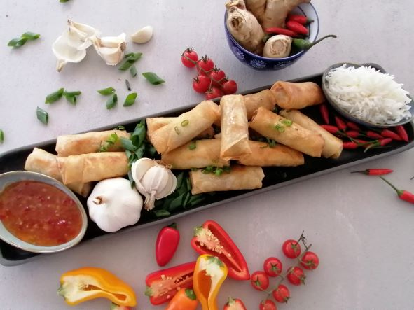

Chilli, Chicken and Rice Spring Rolls

Makes: 40 spring rolls
Prep time: 45 minutes
Cooking time: 15 minutes

Ingredients
30ml (2 tablespoons) oil
1 onion, thinly sliced
2 cloves garlic, crushed
10ml (2 teaspoons) fresh ginger, grated
1 red pepper, thinly sliced
500g finely chopped chicken breast
2 carrots grated
1/4 head of small cabbage, shredded
125ml (½ cup) chopped coriander
375ml (1 ½ cups) cooked Golden Delight Long Grain White Parboiled Thai Rice
45ml (3 tablespoons) soy sauce
Salt and pepper to taste
40 spring roll wrappers, defrosted
Flour mixed to a paste with water
Vegetable oil for shallow frying

Method:
- Heat the oil in a wok or pan.
- Stir fry the onion, garlic, ginger and pepper. Add in the chopped chicken and stir fry until cooked.
- Add the carrots, cabbage and coriander. Stir well and turn the heat to medium-high. Stir fry the vegetables for 2 minutes, or until the carrots have softened.
- Add in the cooked Golden Delight Rice, soy sauce and seasoning and mix well.
- Spread the mixture onto a baking sheet and let it cool. Make sure to prop up the baking sheet on one end so that any excess liquid collects to one side. When the mixture has cooled, discard the liquid.
- In a small bowl, mix the flour and water. This will be used to seal the spring rolls once wrapped.
- Open the spring roll wrapper package and cover the wrappers with a damp towel to prevent them from drying out.
- To fill the spring rolls, place the wrapper in a diamond shape on a clean and dry surface. Place 1 tablespoon of filling near the bottom corner. Fold over the corner and roll tight twice, without leaving air pockets. Fold over the left side, then fold over the other side and keep rolling tight.
- Paint a little flour slurry along the edge and seal.
- Place the spring rolls seam side down and keep them covered with cling wrap to prevent them from drying out.
- Shallow fry in hot vegetable oil turning occasionally until evenly browned. This will take about 2 or 3 minutes. Put them on a plate lined with kitchen paper to drain any excess oil.
- Serve warm with a dipping sauce of choice.

Tips:
- These spring rolls can be prepared in advance and freeze for future use.
- To reduce the fat content, you could steam the filling instead of stir-frying and opt to air fry or bake instead of frying in oil.
- You can use an alternative protein to chicken or keep it completely vegetarian.
- Pair with a peanut or hummus dip to increase the protein and healthy fat content.

